**INVENTION DISCLOSURE FORM**

**INNOTECH PROJECT ID: PCS25-40**

**DEPARTMENT: Computer Science**

**Ques.1. Title of your invention**

“CollegeSearch: A Comprehensive Career Guidance and College Selection Platform”

**Ques.2. Type of Invention**

Web-based software application

**Ques.3. Brief Description of your invention**

This invention is a web-based platform designed to assist students in making informed decisions about their academic and career paths. It provides personalized career counseling, access to comprehensive college databases, and the ability to schedule one-on-one mentorship sessions. Built using the MERN stack (MongoDB, Express.js, React.js, and Node.js), it offers a user-friendly interface and secure backend to streamline the student experience

**Ques.4. Objective of your invention**

1. To help students navigate the complexities of career choices and college admissions.
2. To provide a platform for personalized mentorship and guidance.
3. To centralize and simplify access to college information.
4. To enable students to make confident, well-informed decisions about their futures.

**Ques.5. How to use the invention**

1. Registration/Login: Users register on the platform using their credentials.
2. Dashboard: Access a personalized dashboard to explore options.
3. Search for Colleges: Use filters to find colleges based on location, courses, fees, and rankings.
4. Consult Mentors: Schedule one-on-one mentorship sessions for career guidance.
5. Decision Support: Use recommendations and mentor feedback to finalize choices.
6. Meeting Management: Manage mentorship schedules and progress from the dashboard.

**Ques.6. Problem your invention is solving**

1. **Lack of Access to Reliable Guidance:** Students often struggle to find credible and tailored career advice.
2. **Information Overload:** Overwhelming information about colleges and careers leads to confusion.
3. **Difficulty in Finding Mentors:** Finding experienced professionals for personalized advice is challenging.
4. **Time and Effort:** Simplifies the process of college and career exploration.

**Ques.7. Purpose and object of Invention**

1. Purpose: To bridge the gap between students and reliable academic/career guidance resources.
2. Object: To empower students to make well-informed decisions about their education and future careers while also creating employment opportunities for mentors.

**Ques.8. Discuss potential commercial application of the invention.**

1. Subscription Models: Students pay for premium features like advanced mentorship packages.
2. Affiliate Partnerships**:** Partnering with colleges for admissions-related services.
3. Partnerships: Partnering with colleges for admissions-related services.
4. Job Opportunities: Mentors and career counselors gain a platform for professional engagement.
5. Sponsorships: Collaboration with educational institutions and career development firms.
6. Advertising: Revenue from relevant, non-intrusive advertisements

**Ques.9.** **Provide any additional material (such as photographs, reports, publications, and references to texts or other information material) which may be helpful to an understanding of the invention identify and indicate the specific relevance of each.**

Database Diagrams:

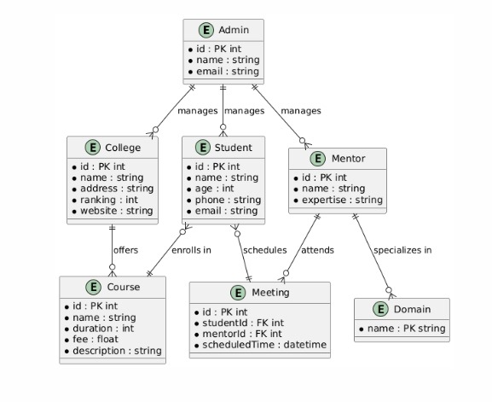

User Interface Mockups:

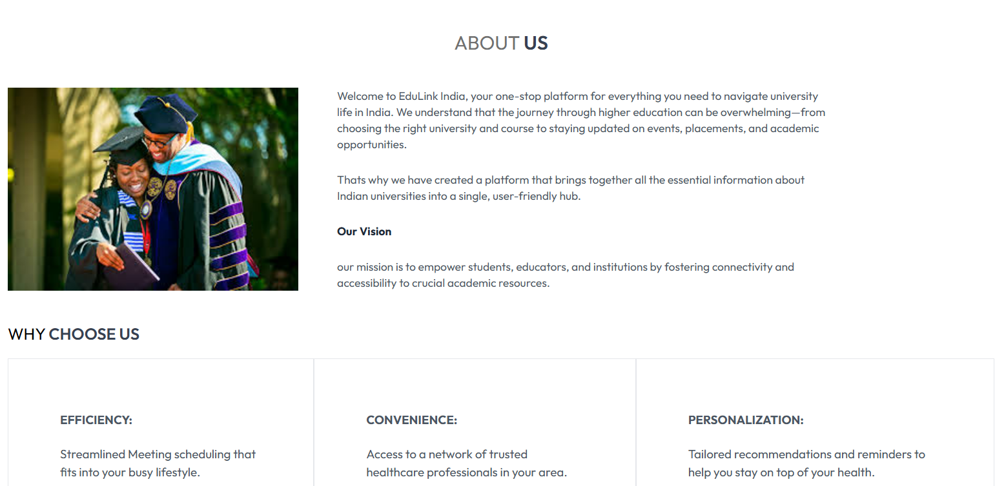

Flowcharts:

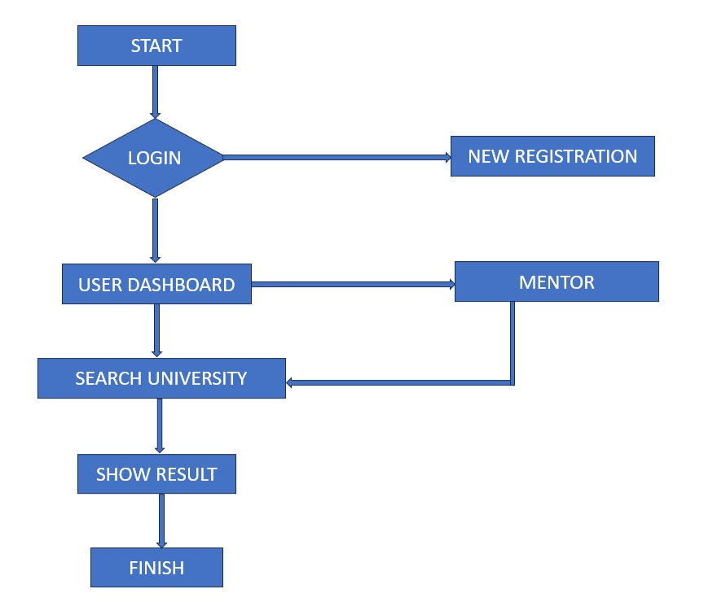

**Ques.10. Abstract**

The Integrated Information Platform for Indian Universities (IIP-IU) is a comprehensive solution designed to address the fragmented and inaccessible information landscape in the Indian higher education ecosystem. The platform is built to serve as a centralized hub for students exploring undergraduate and graduate programs, empowering them with detailed insights into university offerings, such as academic courses, faculty expertise, admission processes, campus facilities, rankings, and alumni networks. A key feature of the platform is its Mentor Guidance System, which bridges the gap between students and industry professionals or academic advisors. This unique feature allows students to schedule one-on-one sessions with mentors, offering personalized career guidance tailored to their individual interests, goals, and academic backgrounds. Whether a student is seeking advice on course selection, understanding industry trends, or planning long-term career strategies, the mentorship feature ensures accessible, high-quality support. The platform leverages modern technologies, including the MERN stack (MongoDB, Express.js, React.js, Node.js), to deliver a scalable, user-friendly, and efficient solution. A responsive and intuitive interface ensures seamless access to critical information across devices, while robust backend infrastructure supports real-time updates on academic calendars, admission deadlines, and program details. Advanced data analytics further enhance the platform by providing personalized recommendations and insights to users. By integrating comprehensive college data and mentorship opportunities in a single platform, the IIP-IU facilitates informed decision-making for students and their families. It also promotes inclusivity, collaboration, and innovation within the educational ecosystem, contributing to the holistic development of students and advancing the competitiveness of Indian higher education.

**Ques.11. Summary of the invention**

The invention is a web-based platform utilizing the MERN stack to streamline the college and career decision-making process. It integrates features such as college search, mentorship scheduling, and personalized dashboards. The invention addresses key student pain points like access to reliable guidance, information overload, and time constraints, making it a practical solution in the EdTech domain.

**Ques.12. Detail description of invention with methodology**

1. Architecture: Built on the MERN stack for scalability and performance.

Database: Stores user, mentor, and meeting data in a secure and efficient manner.

1. User Interface: A single-page application using React.js for seamless navigation.
2. Core Features:

* College Search: Comprehensive filters and search options.
* Mentor Consultations: Securely schedule and manage one-on-one sessions.
* User Dashboard: Personalized overview of activities and decisions.

1. Methodology: Follows agile development practices to ensure a user-centric and iterative approach.

**Ques.13. Applicant and inventor details:**

* **Applicant Name: Prabhat Sehrawat**
* **Institution: Kiet Group of Institution**
* **Email: prabhat.2125cs1041@kiet.edu**
* **Contact: 9084539879**
* **Team Members:** 
  + **Prabhat Sehrawat**
  + **Ashwin Yadav**
  + **Harsh**
  + **Mayank Choudhary**